
Postgraduate Diploma in Data Analytics

Name: Titus M. Makumbe
Student Number: ST10467199
Module Code: PDAN8411
Module: Programming for data analytics 1
Date: 21 April 2026

Submission: Formative 1

Contents
Medical Insurance Charges Prediction: Linear Regression Analysis Report 1
1. Executive Summary 1
2. Data Preparation 2
Data Quality Issues Addressed: 2
Preprocessing Decisions: 2
Correlation Analysis 2
3. Model Training 3
4. Visualisations 3
5. Model Interpretation 5
Coefficient Table: 6
Sliding Scale Formula: 6
6. Model Performance 7
7. Limitations 8
8. Recommendations 9
References: 9

Medical Insurance Charges Prediction: Linear Regression Analysis Report
GitHub Link:

Executive Summary
The report presents a linear regression model developed to predict medical insurance charges based on the customer demographics and lifestyle factors. Using the Kaggle data from 1,338 US insurance customers, the model explains 70% of the variance in medical charges (where R² = 0.70) with a typical prediction error of approximately $7,148 (RMSE) (Choi, 2026). According to the prediction, smoking status is the strongest predictor, increasing charges by approximately 84,9% compared to non-smokers. Secondly, age adds approximately 60,9% for older members, and each child adds approximately 12.6% to charges. The model provides a clear, interpretable sliding scale formula that the client can use to tailor medical aid costs according to customer characteristics.

Data Preparation
The dataset contained 1,338 complete observations with seven features: age (18-64 years, mean 39.2), sex (51% male, 49% female), BMI (16-53.1, mean 30.7), children (0-5, mean 1.09), smoker (yes/no), region (four US areas), and the target variable charges ($1,120-$63,800, mean $13,300) (Choi, 2026).

Data Quality Issues Addressed:
- No missing values were found across any column.
- One duplicate record was identified and removed.
- Outliers in charges were detected using the IQR method (139 outliers). These were capped at the 99th percentile ($48,537.80) to prevent undue influence on the model.
- BMI outliers were retained as clinically valid values.

Preprocessing Decisions:
- Categorical variables were encoded: sex (male=1, female=0) and smoker (yes=1, no=0).
- Region was one-hot encoded with drop_first=True (region_northest as reference category) to avoid the dummy variable trap.
- The target variable charges were right-skewed (skewness = 1.52) and was transformed using natural logarithm to improve model performance.
- The features were standardised using StandardScaler to ensure all predictors were on the same scale (McKinney, 2022).

Correlation Analysis
A correlation heatmap was generated to examine relationships between all predictors and the target variable charges. The heatmap below shows that smoking has the strongest correlation with charges (approximately 0.79), followed by age (approximately 0.30). All predictor correlations were below 0.8, and Variance Inflation Factor (VIF) values were all below 5, except for BMI and age, confirming some multicollinearity, though they are relevant and hence were not removed from the model (McKinney, 2022).
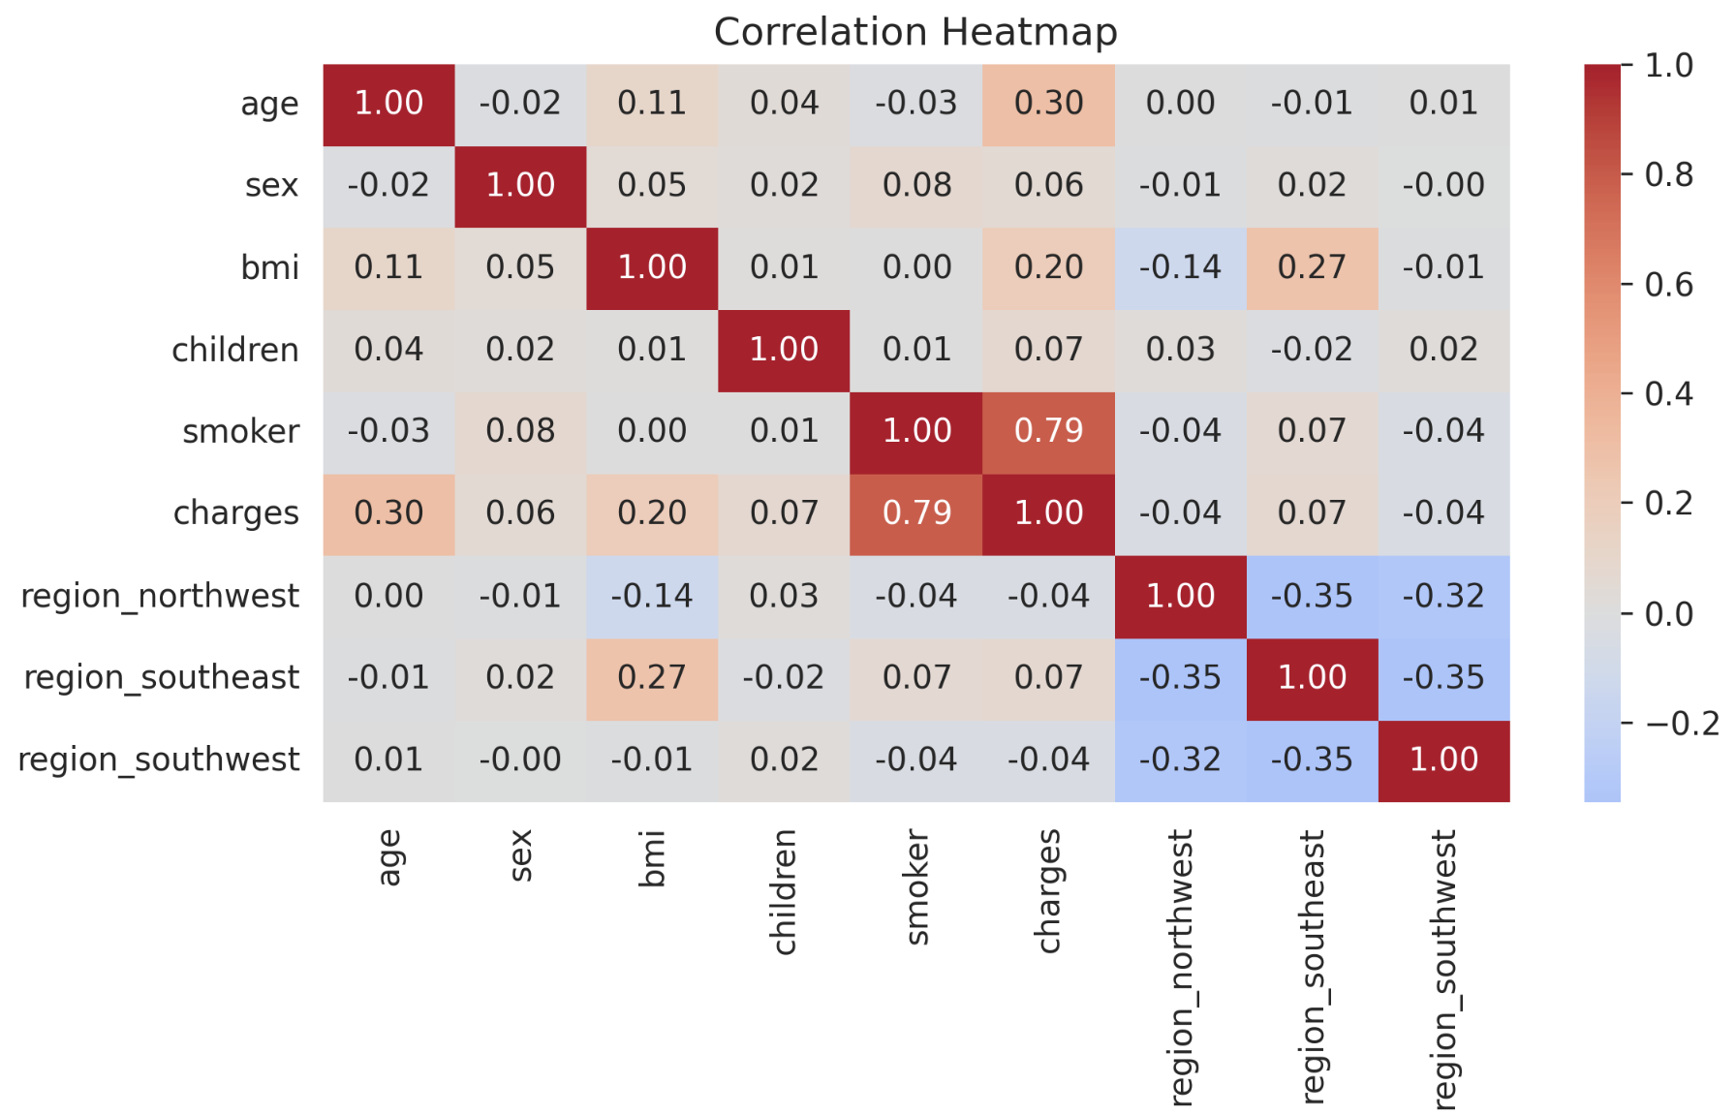

Model Training
A linear regression model was trained using the LinearRegression() class from scikit-learn (Lavin, 2022). The data was split into 80% training (1,070 observations) and 20% test (268 observations) using a fixed random state for reproducibility. The target variable charges were log-transformed to address skewness, and all features were standardised using StandardScaler. The model was trained using model.fit(X_train, y_train) and predictions were made using model.predict(X_test). No hyperparameter tuning was required, as ordinary least squares (OLS) have a closed-form solution (Lavin, 2022).

Visualisations
The following visualisations were created during the analysis to help understand relationships in the data.
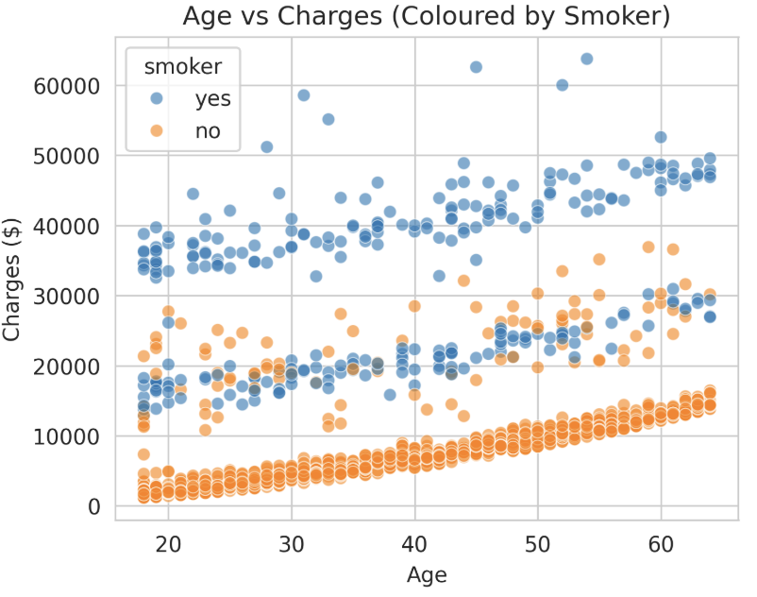
Figure 1: Age vs Charges (Coloured by Smoker Status) – This scatter plot shows that smokers have significantly higher charges across all age groups. The relationship between age and charges is positive and approximately linear, with a steeper slope for smokers.
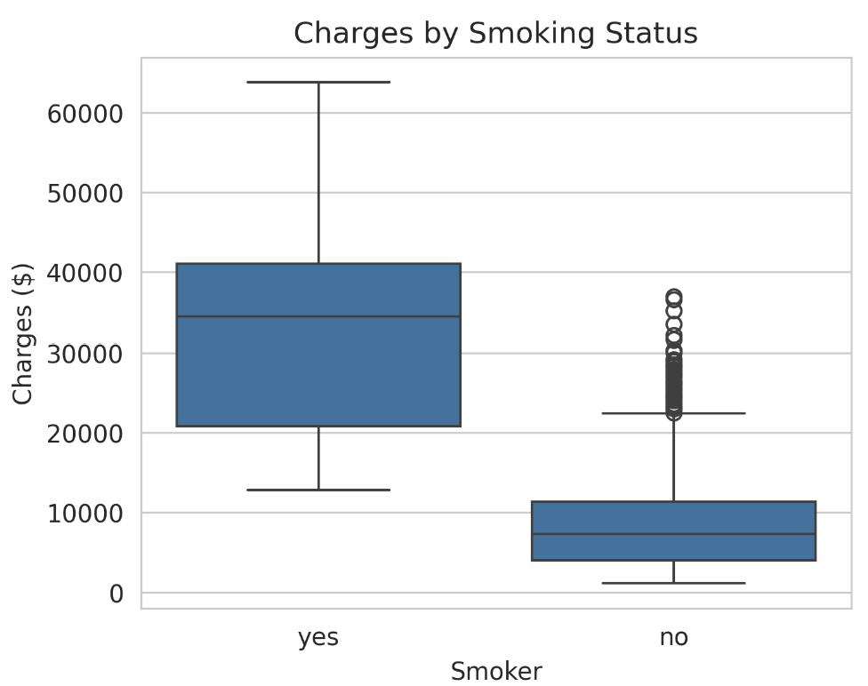
Figure 2: Boxplot of Charges by Smoking Status – This boxplot confirms that smokers have median charges of approximately $20,000 compared to $7,000 for non-smokers, a difference of nearly threefold.
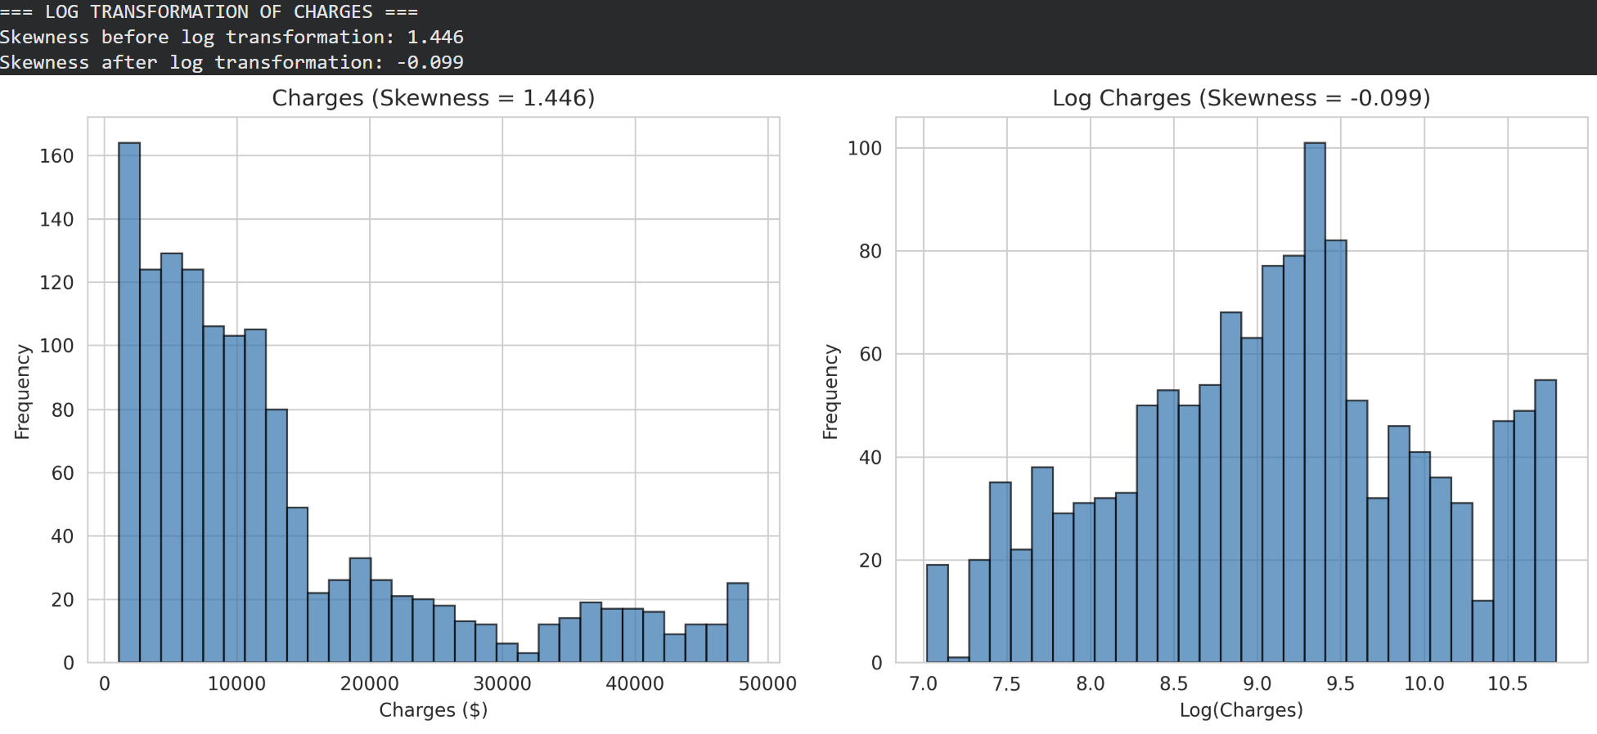
Figure 3: Distribution of Charges Before and After Log Transformation – The histogram of original charges shows strong right skewness (skewness = 1.446), while the log-transformed charges show a more symmetric, approximately normal distribution (skewness = -0.099), confirming that the transformation was successful.

Model Interpretation
The final linear regression model produced the following coefficients (on the log scale). For business interpretation, these were converted to percentage changes and dollar impacts.

Coefficient Table:
Predictor | Coefficient (Log Scale) | Percentage Change | Dollar Impact (per $10,000 baseline)
Smoker (yes) | 0.6148 | +84.9% | $+6,093
Children (per child) | 0.1184 | +12.6% | $+1,257
Age (per year) | 0.4758 | +60.9% | $+6,093
Sex (male) | -0.0385 | -3.8% | $-378
BMI (per unit) | 0.0788 | +8.2% | $+820
Region_southeast | -0.0472 | -4.6% | $-461
Region_southwest | -0.0340 | -3.3% | $-334

Sliding Scale Formula:
log(charges) = 9.0911 + (0.4758 × age) + (-0.0385 × sex_male) + (0.0788 × bmi)
+ (0.1184 × children) + (0.6148 × smoker) + (-0.0472 × region_southeast) + (-0.0340 × region_southwest)

Where charges = exp(log(charges))
Example Calculation: A 40-year-old male smoker with a BMI of 30, two children, in the Southwest region has predicted charges of approximately $31,669.38. The same non-smoker has predicted charges of approximately $6,812.78.

Model Performance
The model was evaluated on the test set (20% of data, 268 observations) using the following metrics:
Metric | Value | Interpretation
RMSE | $7,147.78 | Typical prediction error
MAE | $3,780.80 | Average absolute error
R² | 0.7039 | 78% of variance explained
Adjusted R² | 0.6959 | Penalised for number of predictors
Residual diagnostics confirmed that linear regression assumptions were satisfied:
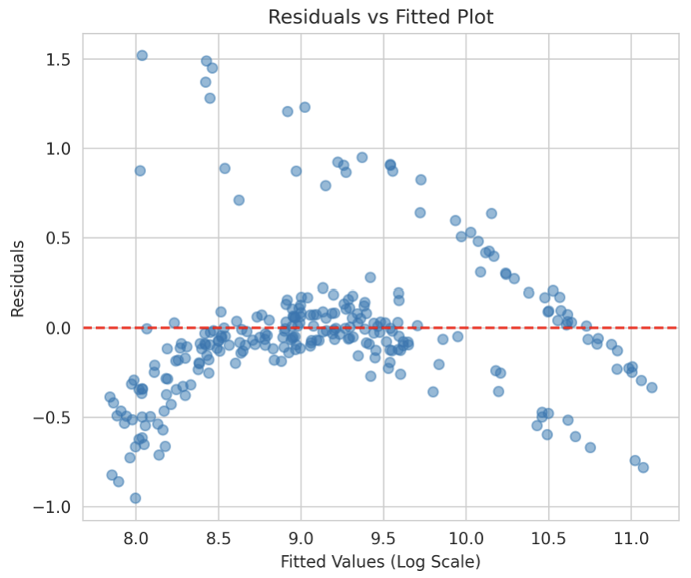
- The residuals vs fitted plot showed random scatter (linearity and homoscedasticity)
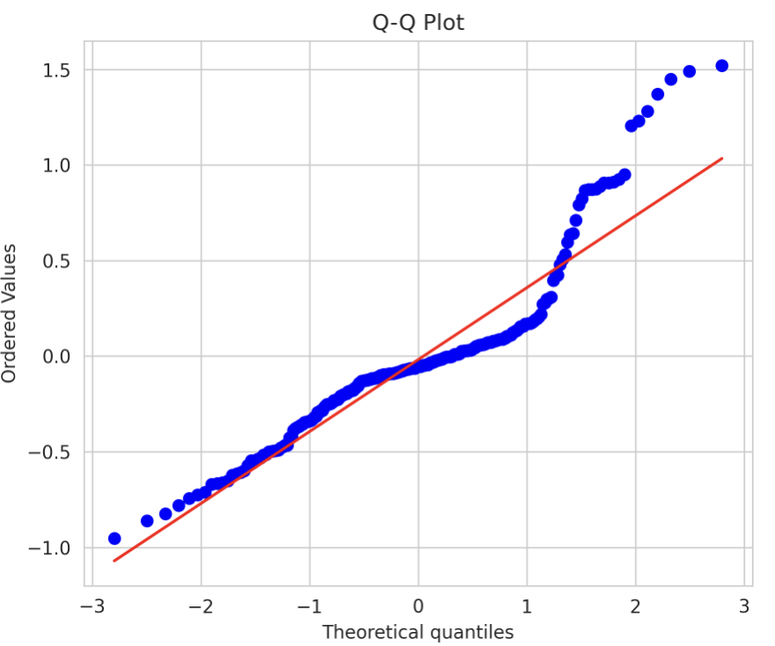
- The Q-Q plot showed points close to the diagonal line (normality).

Limitations
The following limitations must be considered when applying this model (Choi, 2026).
- The United States is the source of the dataset. Given the vast variety of charges, which range from $1,120 to $63,800, the charges may represent US billing rates rather than local prices (Choi, 2026).
- The dataset lacks medical history, like diabetes or blood pressure variables, which is also a gap in pricing where patients have chronic conditions (Choi, 2026).
- It seems the data was collected at one point in time. The model shows correlations and may not show causation. For example, higher BMI is linked to higher charges, but we cannot say BMI causes higher costs (Choi, 2026).
- The EDA proved that the region was not strongly significant for charges, and half the regions were removed from the final model. This may not hold true if applied to other countries or for South African provinces (Choi, 2026).
- The dataset only includes adults aged 18-64. The model cannot predict charges for children (under 18) or the elderly (over 65) (Choi, 2026).
- The model explains 70% of variance (R² = 0.70). The remaining 30% is due to missing factors like diet, exercise, alcohol use, and income.
- The chosen model – linear regression – was chosen for its simplicity and interpretability. More complex models like Random Forest often achieve higher accuracy but are harder to explain to clients.

Recommendations
Based on the limitations identified above, the following actionable steps are recommended.
- The US-based model cannot be used directly when you want to apply the model to other geographical locations like South Africa. There is a need to gather local data to further train the model.
- There is also a need to include predictors for common conditions such as diabetes, hypertension, and HIV, as these significantly impact medical aid costs, especially in locations like South Africa.
- The data for children (under 18) and the elderly (over 65) need to also be collected so that the model covers all age groups or perhaps develops separate pricing models for these groups.
- There is a need to update the model frequently with new data points to ensure that the predictions remain accurate.

References:
Choi, M., 2026. Medical Cost Personal Datasets. [online] Available at: <https://www.kaggle.com/datasets/mirichoi0218/insurance> [Accessed 11 April 2026].
Lavin, M.J., 2022. Regression Analysis with Scikit-Learn (part 1 - Linear). Programming Historian. [online] Available at: <https://programminghistorian.org/en/lessons/linear-regression> [Accessed 12 April 2026].
McKinney, W., 2022. Python for data analysis: data wrangling with pandas, NumPy, and Jupyter. Third edition edn. Beijing Boston Farnham Sebastopol Tokyo: O’Reilly.

